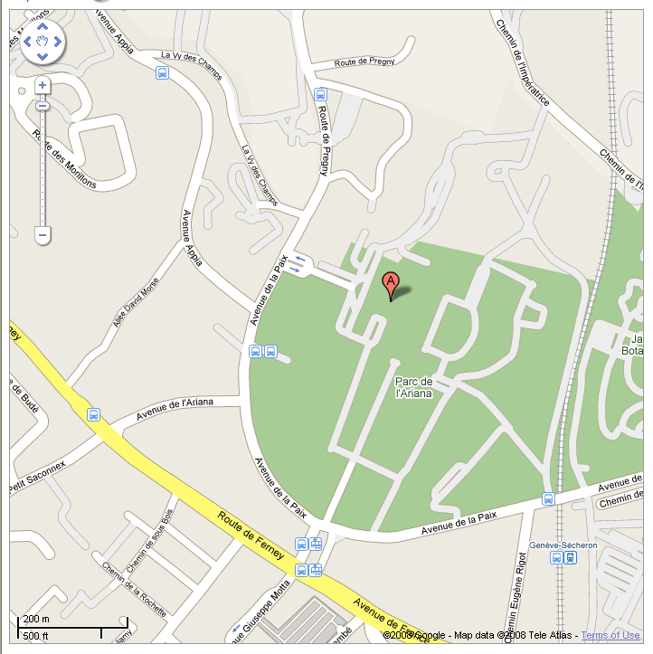
Pregny Gate
Palais des Nations

Entry to the Palais des Nations (portail de Pregny)
Croix Rouge

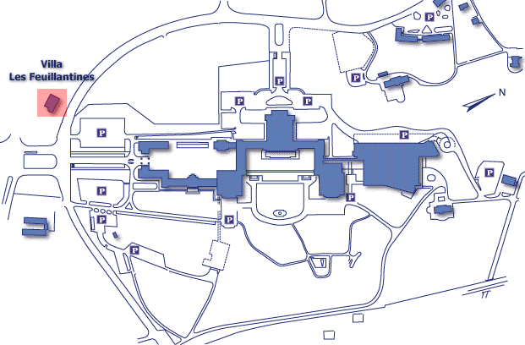
DOOR 40

Room XXVII
1st Floor
DOOR 40

Room XII
3rd Floor
Place des Nations

Bank

